MGMS – Sub project allocation

Detailed Design Document

Ver. 1.4

Version History
Version # | Date | Description
1.0 | 16-Oct-2010 | First Draft
1.1 | 17-Nov-2010 | Table fields

Table of Contents

Version History 2
1 Introduction 4
1.1 Purpose 4
1.2 Scope 4
1.3 Assumptions 4
1.4 Constraints 4
2 Data Dictionary 11

Introduction

Purpose

This document provides the detailed design specifications for the Multisite Grant Management System project.

This is not a project plan nor does it detail the source code. It is a guide for system architecture and development, not for phasing, timelines or deliverables.

Finally, this is a ‘living document’ and the specification will change, continuously, as the project proceeds. More details will be added and the existing information edited as the requirements, architecture and design evolve in the course of the project.

Scope

Assumptions

Constraints

Sub allocate projects

Create sub project
The institution can divide the main project to sub projects to be further assigned to other institutions.
- The details saved of a sub project are: name, start & end dates, receiving institution, amount of allocation, sanction order number (Letter no :), date of allocation and any remarks by the user.
- Now the user’s institution has become the “Grantor” who has assigned a (sub) project and allocated an associated grant amount to the receiving institution, the Grantee.
- What is categorized as “sub project” by the grantor is categorized as “project” by the grantee
- Grant allocations may be made any number of times to a grantee, for a project.
- The same project cannot be assigned to two/more different institutions.
- (The system validates that sub-project start and end date falls within the start and end date of the main project).
- After creating a subproject, any number of associated documents may be uploaded into the GMS, for future reference.

Screen & Control Description

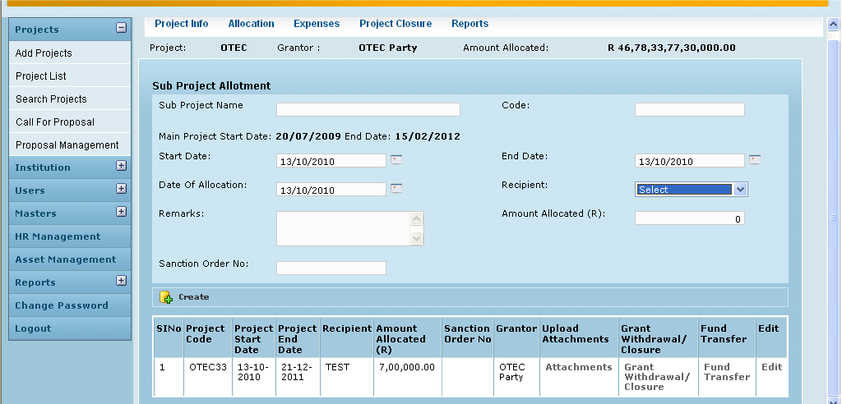

Field /Label | Input-Control | Data Type | Remarks/db table>field
Project: | Auto-populated | varchar(255) | projects>code
Grantor: | Auto-populated | varchar(255) | party>code
Amount Allocated: | Auto-populated | double | grant_allocation>amount
Sub Project Allotment
Sub Project Name: | Textbox | varchar(255) | projects>name
Code: | Textbox | varchar(255) | projects>code
Main Project Start Date: | Auto-populated | datetime | projects> project_start_date
End Date | Auto-populated | datetime | projects> project_end_date
Start Date | textbox-calendar | datetime | projects> project_start_date
End Date | textbox-calendar | datetime | projects> project_end_date
Recipient: | Listbox | varchar(255) | party>code
Date of Allocation: | textbox-calendar | datetime | grant_allocation>date-of_allocation
Amounted Allocated (Rs): | Textbox | double | grant_allocation>amount_allocated
Remarks: | Textarea | varchar(255) | grant_allocation>remarks
Sanction Order No: | Textbox | varchar(255) | grant_allocation>sanction_order_no
Create | Button
SlNo | auto increment-populated
Project Code: | Auto-populated | varchar(255) | projects>code
Project Start Date: | Auto-populated | datetime | projects> project_start_date
Project End Date: | Auto-populated | datetime | projects> project_end_date
Recipient: | Auto-populated | varchar(255) | party>code
Amount Allocated: | Auto-populated | double | grant_allocation>amount_allocated
Sanction Order No: | Auto-populated | varchar(255) | grant_allocation>sanction_order_no
Grantor | Auto-populated | varchar(255) | party>code
Upload Attachments | Button |  | Opens up page for browsing-uploading attachments
Grant/Withdrawal//Closure | Button |  | Opens up page where user can record the particular grant’s status
Fund Transfer | Button |  | Opens up Fund Transfer page where user can record associated fund transfers made to grantee.
Edit | Button |  | Can edit the fields above

Associated Tables

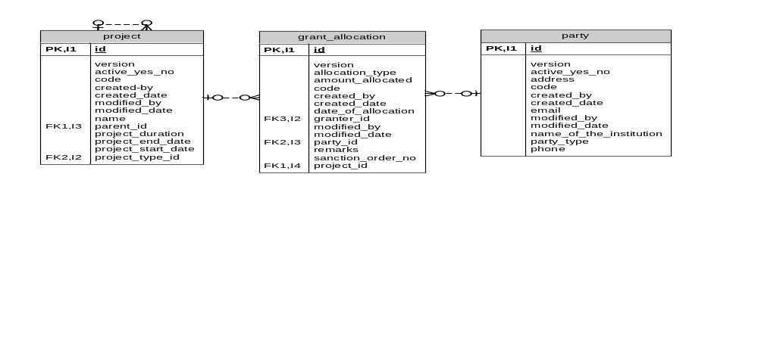

Attachments

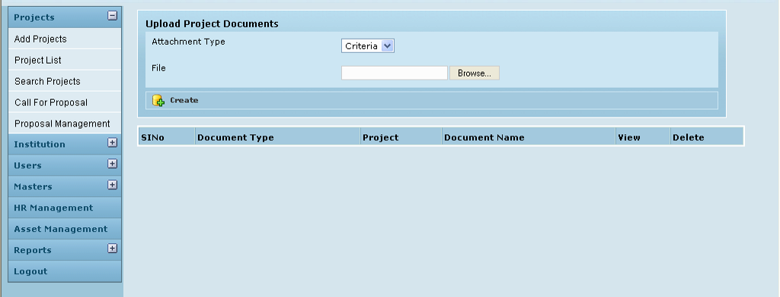

Field /Label | Input-Control | Data Type | Remarks/db table>field
Upload Project Documents
Attachment Type | Listbox | varchar(255) | attachment_type>type
File | textbox, “Browse” button
Create | button
Sl No | Auto increment/ populated
Attachment Type | Auto populated | varchar(255) | attachment_type>type
Project | Auto populated | varchar(255) | projects>code
Document Name | Auto populated
View | Button
Delete | Button

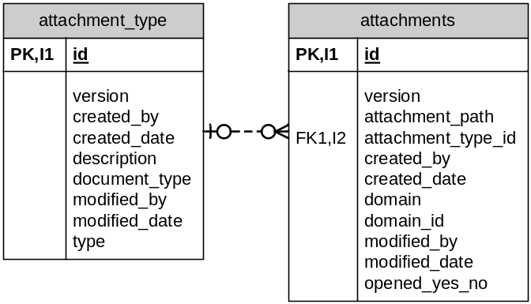

Withdrawal/Closure

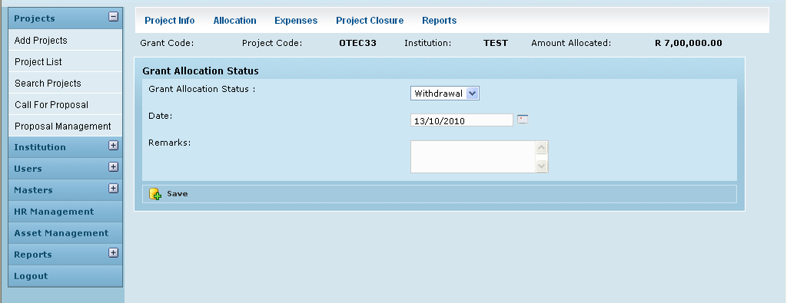

Field /Label | Input-Control | Data Type | Remarks/db table>field
Grant Code: | Auto populated | varchar(255) | grant_allocation>code
Project Code: | Auto populated | varchar(255) | projects>code
Institution: | Auto populated | varchar(255) | party>name_of_the_institution
Amount Allocated: | Auto populated | double | grant_allocation>amount_allocated
Grant Allocation Status
Grant Allocation Status | Listbox | varchar(255) | grant_allocation_tracking>grant_allocation_status
Date: | textbox-calendar | datetime | grant_allocation_tracking>date_of_tracking
Remarks: | Textarea | varchar(255) | grant_allocation_tracking>remarks
Save | Button

Associated Tables below

Fund transfer

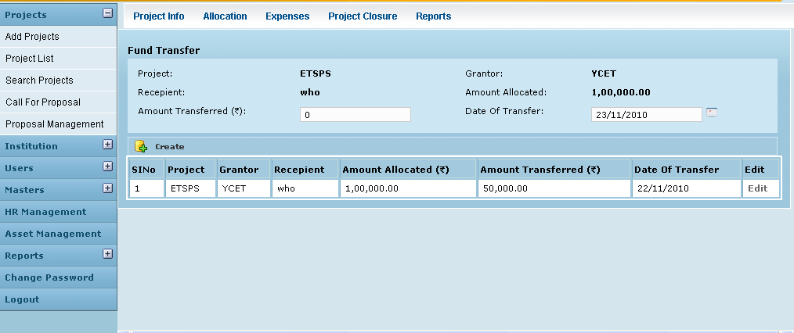

Field /Label | Input-Control | Data Type | Remarks/db table>field
Fund Transfer
Project: | Auto-populated | varchar(255) | projects>code
Grantor: | Auto-populated | varchar(255) | party>name-of_the_institution
Recepient: | Auto-populated | varchar(255) | party>code
Amount Allocated: | Auto-populated | double | grant_allocation>amount_allocated
Amount Transferred: | Textbox | double | Fund_transfer>amount
Date of Transfer: | Textbox-calendar | datetime | Fund_transfer>date_of_transfer
Create | Button

Associated Tables
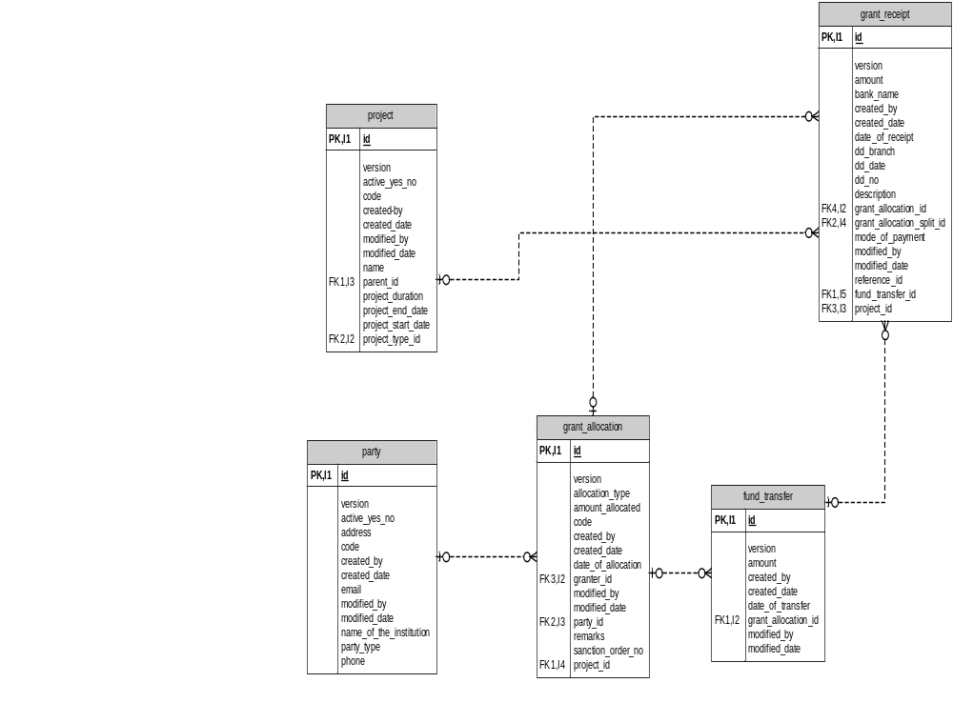

Data Dictionary

